Vector Suitability Analysis Ferret Habitat Reintroduction
Name: Joachim Vogl
WELD county Black-footed ferret reintroduction analysis summary:
The total amount of suitable areas of polygons on the map turned out to be primarily congregated in the northern and far east/west sides of the county. In building my model, I used the union and intersect tools in order to select the map features and areas of the map that are desired to display the final suitable areas but then excluded the areas that I didn’t want to display.
The intention of the clip function is to extract only the relevant portions of each dataset within Weld County. In this case, that included roads, municipalities, prairie dog potential, and land ownership. The Union tool combined the layers of land ownership and prairie dog colony potential to integrate attributes, while the Intersect tool narrowed the results to areas that met all suitability criteria (distance from roads, land ownership, and colony potential). A buffer tool was also used to create a one-mile zone around municipalities to exclude areas too close to urban development.
The results of these queries were that the total suitable area for potential black-footed ferret reintroduction in Weld County was approximately 329,000 acres. The final map displayed distinct polygons representing suitable areas, mostly located in open grasslands away from municipalities and major roadways. These areas were primarily in central and northeastern Weld County, where prairie dog colony potential and appropriate land ownership overlapped.
Black Footed Ferret Reintroduction Vector Suitability Analysis:
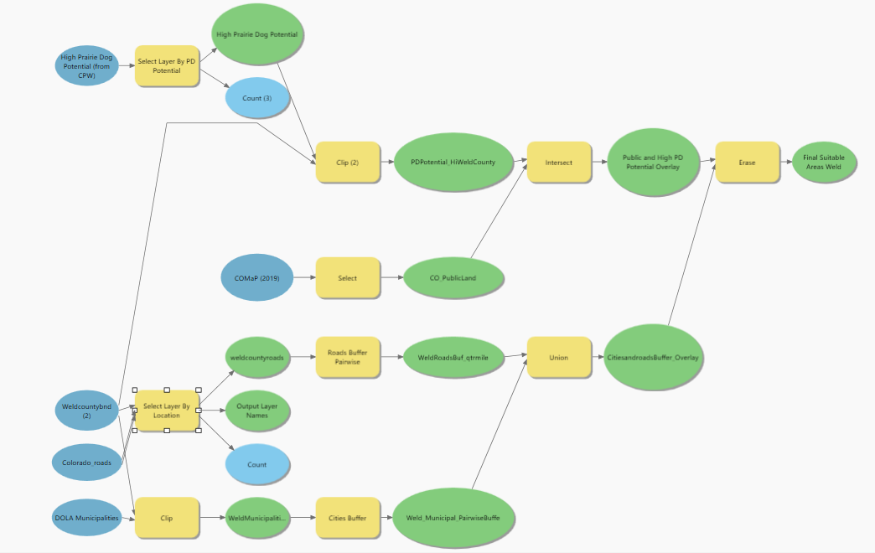

Map figure of Weld County suitable areas with legible and aesthetic symbology:
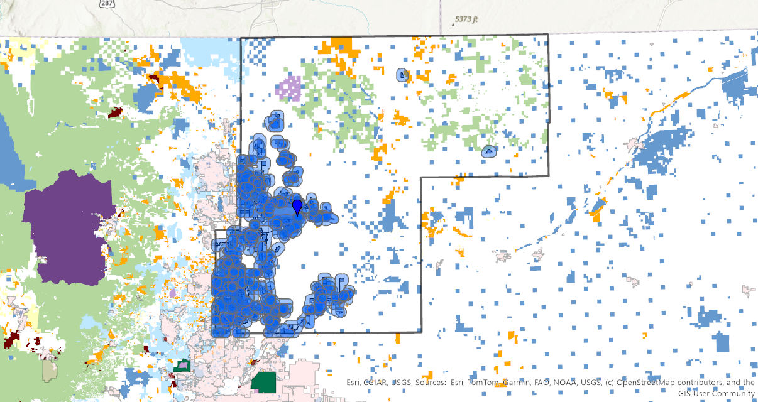

LARIMER county Black-footed ferret reintroduction analysis summary:
The intention of the clip function was to limit all analysis layers such as roads, municipalities, and prairie dog habitat to the Weld County boundary. And to get rid of the other stuff and only keep the suitability calculations visible on the map to display the areas where prairie dogs were likely to be found. This ensured that all subsequent processing and suitability calculations occurred only within the county extent.
The resulting map shows that the total suitable area for potential black-footed ferret reintroduction in Weld County was approximately 329,000 acres. Most ferret are aggregated in the northern area of the county and the only habitat that is not urbanized is to the far north and to the east. The final map displays distinct polygons representing suitable areas, mostly located in open grasslands away from municipalities and major roadways. These areas were primarily in central and northeastern Weld County, where prairie dog colony potential and appropriate land ownership overlapped.

Map figure of Larimer County suitable areas with legible and aesthetic symbology:
